Kube Config
- A Kubeconfig is a YAML file with all the Kubernetes cluster details, certificates, and secret tokens to authenticate the cluster. You might get this config file directly from the cluster administrator or from a cloud platform if you are using a managed Kubernetes cluster.
- Saved in folder : $kube/.kube/config

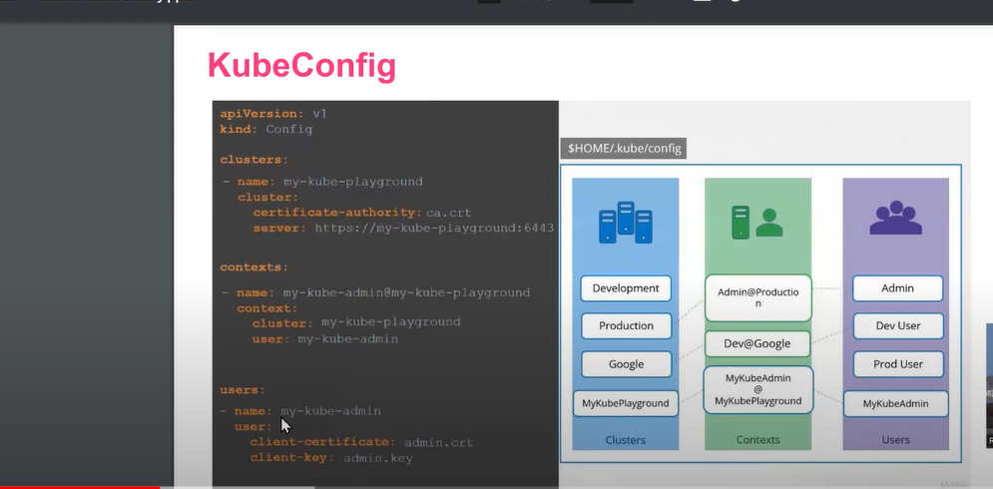

- Kubectl config -h : for getting different command for kubeconfig

Eg: kubectl config get-users

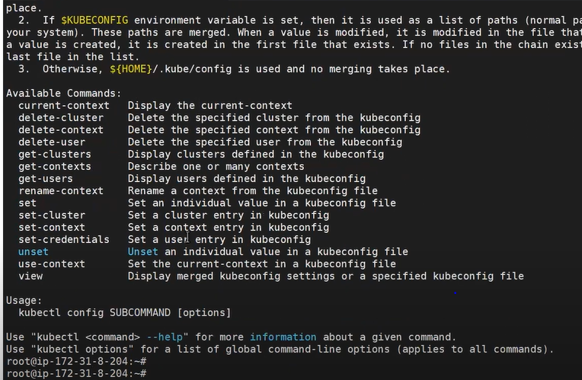
- Kind create cluster –name mycluster : command to create cluster

How to change one cluster to another?

- Kubectl config use-context kind-kind
Note : here kind-kind is the context of another cluster, using context we are switching to different cluster.

